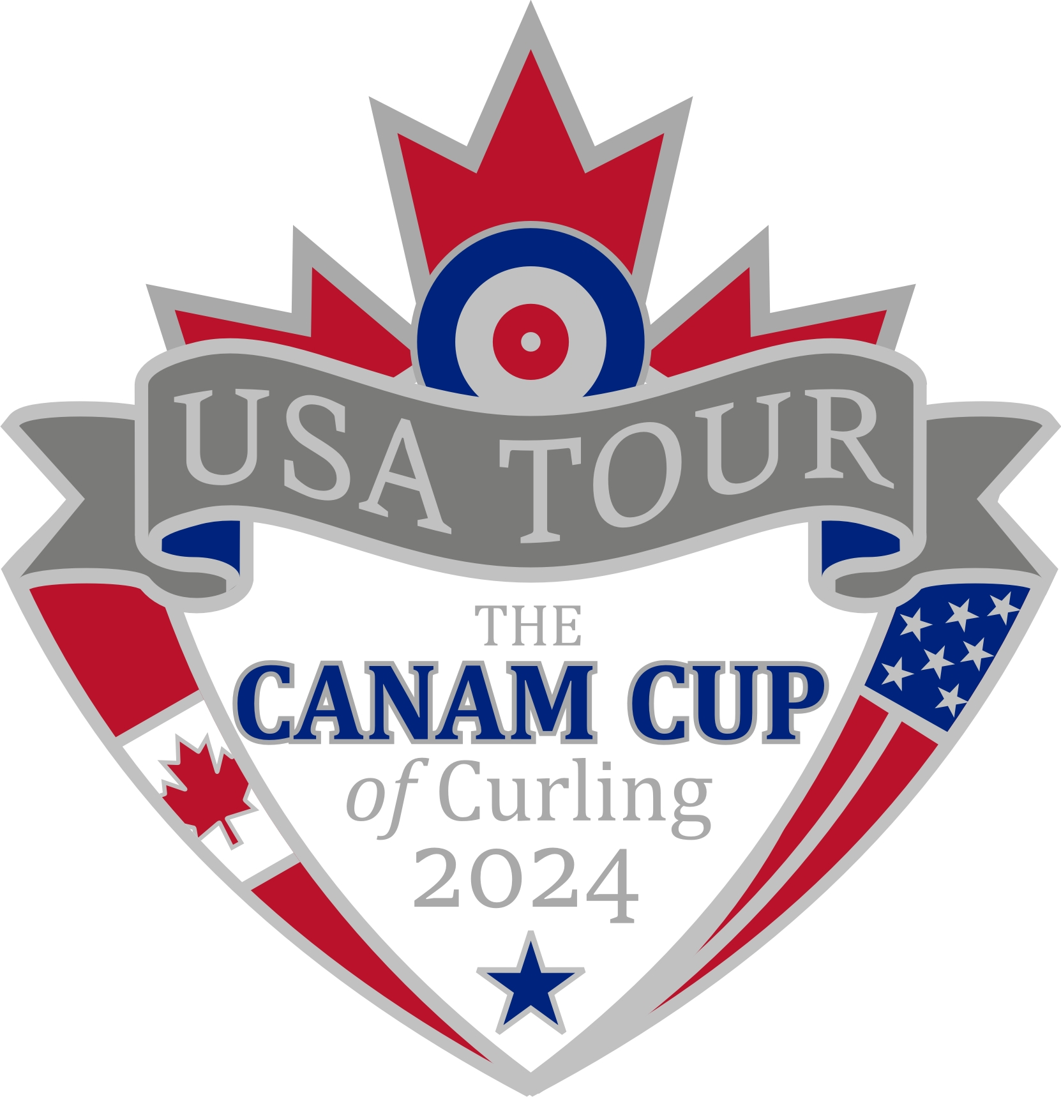
2024 Canadian Men's Curling Friendship Tour (Can-Am)
of Northeastern United States
November 2024
Dear Tour Applicant:
Thank you for your interest in the 2024 Canadian Men's Curling Friendship Tour to United States which will take place in November 2024. This will be the second Can-Am Tour, the first of which involved the American men touring many of our Eastern Canada curling clubs in 2019.
The Can-Am tour was created in 2018 by the President of the United States Curling Association Rich Lepping and the President of Canadian Curling Association Peter Inch whom, together, commissioned a Sterling Silver trophy to be awarded to the Tour Champions at the completion of the tour. The Can-Am Tour was created from a shared vision of promoting the sport of Curling and strengthening relationships between members of curling clubs in our respective countries. The Tour takes place every four years rotating between Canada and the United States.
The 2024 Can-Am Tour will take place over a three-week period in November 2024 and is expected to involve stops at 20 or more curling clubs throughout the Northeastern States including Minnesota, Wisconsin, Illinois, Michigan, Ohio, and Maryland (the specific list of clubs and states may be modified as the trip planning is completed).
Below is an outline of what has been determined so far:
Tour Dates: Approximately 21 days in November, 2024
Tour Cost: An approximate cost, per player for this Can-Am Tour is estimated at CDN $8,000-$9,500 based on the following tour inclusions:
- Land transportation costs while in United States
- Hotel Accommodation (based on 2 players per room)
- Meals
- Team Clothing (on-ice uniforms and off-ice clothing)
- Curling equipment (brooms)
- Social events (limited sightseeing events and banquets)
- Tour pins, bannerettes and special gifts for host clubs.

Note: There will be additional personal costs involved that would include:
Travel from home to the tour starting location and from the tour ending location to home, host pin costs and any personal costs incurred outside activities provided by the tour.

Tour Itinerary: Approximately 20+ games will be scheduled to be played in various Northeastern United States curling clubs and centres. A proposed itinerary is being prepared by the United States Organizing Committee but is likely to include the following states: Minnesota, Wisconsin, Illinois, Michigan, Ohio, and Maryland. The schedule will also provide for "free time" for some sightseeing along the tour.
Tour Trophy: The Inch Lepping Trophy will be presented to the winning team at the end of the Tour. Team United States are the defending champions!
Should you require any clarification or have any questions, please do not hesitate to contact me at your earliest convenience.
Finally, I look forward to meeting and working with each member of the Canadian Team as we formulate plans for an exciting Can-Am Tour in November, 2024!
Yours in Curling,

Peter Inch
Chairman - 2024 Can-Am Tour
Tel: 519-709-2257
Email: peterinch22@gmail.com

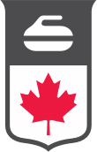
Page 1 of 3

2024 Can-Am Tour of Northeastern United States
APPLICATION FORM
SECTION 1:

FULL NAME (as shown on passport)
MAILING ADDRESS
TELEPHONE: | Home:
 | Cell:
EMAIL ADDRESS
OCCUPATION:
NAME OF THE CURLING CLUB YOU ARE AFFILIATED WITH:

Page 2 of 3

CURLING RESUMÉ

Outline your involvement with the sport of curling through your curling club (must be a club affiliated with Curling Canada and /or Provincial Curling Association). Where possible, indicate why you love curling, why you are excited to participate in the 2024 Can-Am Tour, your level of experience, preferred position, and any contribution(s) you may have been involved with that helped with the growth of curling.

OTHER SPORTS, HOBBIES OR COMMUNITY INTERESTS

Page 3 of 3
I understand that the cost of this 3-week tour is approximately CDN $8,000-$9,500. Should I be selected as one of the members, I am willing to forward a 50% advance deposit toward the cost of the Tour in winter of 2024 at a date specified by the Can-Am Organizing Committee.

Signature:
Date:

DEADLINE FOR SUBMISSION OF APPLICATIONS
IS MARCH 15, 2024

APPLICATIONS TO BE SUBMITTED TO:
peterinch22@gmail.com
and copy karen.ryan@curling.ca

