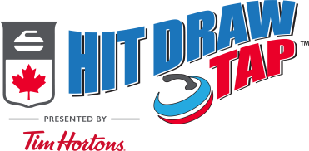
THE “HIT”
GOAL: Hit the positioned rock and stay in the rings.
AGE GROUP | 6-8  Will be determined based upon registration | 9-15  Will be determined based upon registration.
MODIFICATION | SHORT GAME | NONE
SPECIAL RULES | - Must keep their hack foot in their designated hack (ie: right handed throwers use left hack)  - Contact with the pre-set rock must be made for any points to count.  - The pre-set rock DOES NOT have to be removed from play | - Contact with the pre-set rock must be made for any points to count, the pre-set rock DOES NOT have to be removed from play
SET-UP | Rock to be hit is set-up behind the button
SCORING  Points are assigned based upon where the THROWN ROCK rolls to.  Scoring for all age groups is the same. | 5 points: if the thrown rock touches the button  4 points: if the thrown rock rolls and touches the 4 foot  3 points: if the thrown rock rolls and touches the 8 foot  2 points: if the thrown rock rolls and touches the 12 foot  1 point: if the thrown rock makes contact and rolls out of the rings.  *Contact with the pre-set rock must be made for any points to count.  * the pre-set rock does not have to be removed from play.
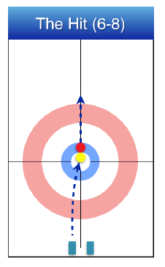
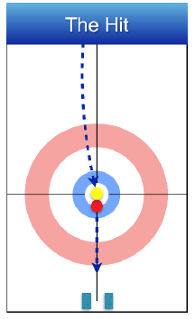
The Hit (6-8) is the modified version set-up using the close house to the hack.
The modified version will be used if there is a 6-8 category, based upon the registrations that we receive.
The regular hit set-up uses the entire length of the ice.
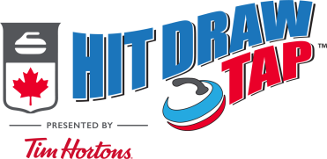
THE “DRAW”
GOAL: Draw as close to the pin as possible.
MODIFICATION | SHORT GAME | NONE
SPECIAL RULES | - Must keep their hack foot in their designated hack (ie: right handed thrower use left hack) | - Must keep their hack foot in the designated hack (ie: right handed thrower use left hack)
SET-UP | No Set-Up
SCORING  Points are assigned based upon where the thrown rock stops.  *Scoring is different for the 6-8 group than the 9-15 group(s) | 5 points: the rock fully covers the pin  4 points: if the rock touches the button  3 points: if the rock touches the 4 foot  2 points: if the rock touches the 8 foot  1 Point: if the rock touches the 12 foot | 5 points: the rock touches the button  4 points: the rock touches the 4 foot  3 points: the rock touches the 8 foot  2 points: if the rock touches the 12 foot  1 Point: if the rock stops in the free guard zone
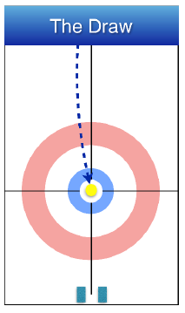
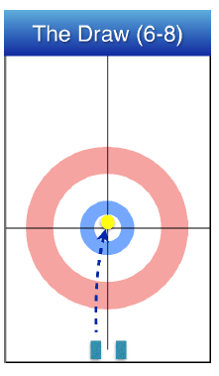
The Draw (6-8) is the modified version set-up uses the close house to the hack.
The modified version will be used if there is a 6-8 category, based upon the registrations that we receive.
The regular draw shot uses the entire length of the ice.

THE “TAP”
GOAL: Is to promote a rock from the 12 foot to the button.
MODIFICATION | SHORT GAME | NONE
SPECIAL RULES | - Must keep their hack foot in their designated hack (ie: right handed thrower use left hack) | - Must keep their hack foot in the designated hack (ie: right handed thrower use left hack)
SET-UP | Rock is positioned bisecting the centre line at the top of the rings.
SCORING  Points are assigned based upon where the tapped rock stops.  *Scoring is the same for all groups. | 5 points: if the tapped rock touches the button  4 points: if the tapped rock touches the 4 foot  3 points: if the tapped rock touches the 8 foot  2 points: if the tapped rock touches the 12 foot  1 Point: if the tapped rock goes through the rings after contact.
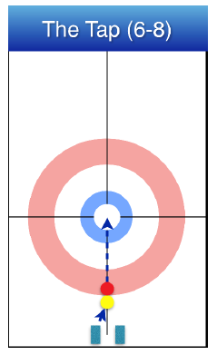
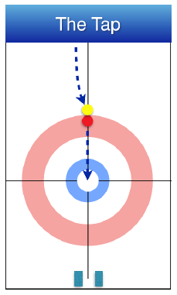

The Tap (6-8) is the modified version set-up where the pre-set rock is placed at the top of the rings closes to the hack.
The modified version will be used if there is a 6-8 category, based upon the registrations that we receive.
The regular tap shot uses the entire length of the ice.

