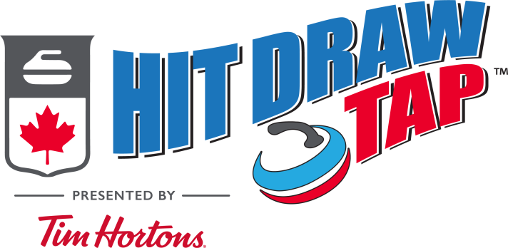

HIT DRAW TAP RULES
- No brushing is allowed during the competition.
- Regulation Curling Rocks only.
- Full sheet length of ice (unless otherwise indicated).
- Someone (parent, volunteer, or other curler) can hold the broom for the thrower.
  - We will be asking the BC Men’s & Women’s Competitors to assist as well.
- All participants’ guardians must sign the Participant Registration Form/ Assumption of risk before participating in any Hit Draw Tap Competition
- Each participant is allowed two practice shots during the pre-competition practice.
  - 1 Draw Shot
  - 1 Hit Shot
- Ties in a category will be determined with a “sudden death” draw to the button.
  - The draw is repeated until a winner is determined.
- If at any point a decision cannot be made as to the score of a shot, the decision shall always favour the participant.
Scoring
- Each athlete will have five attempts at each shot.
- The score is cumulative.
- The participants will be ranked on their total score within their group to determine the 1st-3rd place winners.
- In all situations, if a score cannot be clearly determined, the decision shall be made in favour of the participant (ie: round up to the higher of the two scores).

